U3A Stawell Newsletter
Term 4 and Presidents Report
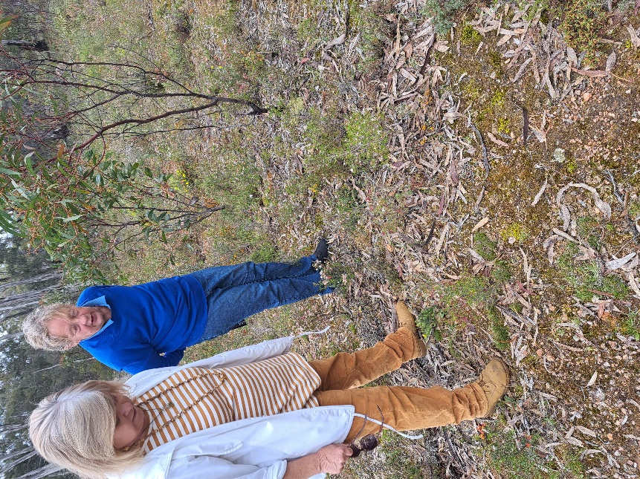
We started the term with a wildflower walk a lovely morning despite the gloomy weather forecast the lovely flowers we saw caused some of us to return to the scene and explore further afield. Ivy and Irene ventured across the Deep Lead road found the Canada Hill track and walked passed the bee hives and there was the reward, a beautiful field of wildflowers even better than the day before. After our walk we enjoyed a great meal at The New Hong Restaurant.
We have a busy 4th term with a Melbourne Cup Lunch and Movie we will show an oldie but goodie. Joy Harrington put forward the idea to show The Sting with Robert Redford and Paul Newman, We are doing a Bring A Plate lunch this year. Can we all bring a plate of food to share. Cheryl will take the details of your offerings so we don’t all bring Asparagus Rolls! Bring a wine glass as I have some champagne to share. We will have a cup sweep and watch the cup on the big screen
This has been a great year for us the presentations of our choice of pioneers brought stories of some famous and some personally famous all exceptional pioneers in their chosen field. We have enjoyed visits to diverse places and in general broadened our horizons. Next year Historic Houses is proposed as our presentation task. Christmas Tree Festival again this year can we win twice?.
We have a speaker engaged Dr Greg Kerr who will talk about his work in the Tagging of Birds he is a member of Nature Glenelg Trust based in Hamilton. He will be our guest speaker December 5th 2023.
This term we will have a travel talk among other programs. Art Group is doing well and the new artists are producing good works, Cards is continuing to attract new players and Friday Coffee and Chat is a most pleasant relaxing time out for those of us who meet up weekly. All in all we seem to be in our happy place.
Gabby October 7th 2023

