NEWSLETTER
Plus, President’s and Publicity Reports
U3A Stawell
Term 3, 2021
Term 2 ended on a high note we were able to take delivery of our new laptop computer, Bluetooth speaker, and Projector. A $1000.00 grant from U3A network the purpose behind this grant is to allow members to familiarize themselves with digital technology. The equipment is available on a short loan basis to assist with programs, classes, presentations and to help with researching any presentation members plan to give. Do take advantage of this equipment I have found once you give yourself over to the technology the uses for everyday life just grow and grow.
The world is still in the grip of Covid 19 and like everyone we are coping we need our full metre of flexibility! Masks, Handwashing QR registering, Lockdowns, and Social Distancing all part of the norm as well as now we must think very positively to get our JABs. I have faith we will eventually return to a life less restricted.
Two new programs this this term Book Club is off to a flying start three read, enjoyed, and understood! Thanks to Karen Jenkins for taking up the role of Book Club coordinator. Cards For Fun on Wednesday morning, another time we are spending in healthy pursuit for our brains.
The movie Mason and I are making is a learning curve I would never have tackled this in my right mind Yes, I did it for the money (the U3A network grant of $800.00) was handy then. I tell you the editing done on films is the reason they have $1,000,000.00 budgets!
While we were in Lockdown two interesting events occurred.
Mason has a full showing of his works on paper in Liv ’Indi Café and more in the Café SHACC here in Stawell. Goff Letts Memoirs have been published and have hit the bookshops. Stawell News Agency have copies, just look for “Where the Brolgas Dance” Both Goff and Mason have been active members of U3A Stawell.
Third term will be a challenge to us with the restrictions regarding size of groups who can meet together in the library as Kerry Wilson (librarian) lets me know the rules u3a Stawell committee will let you know any changes. Please be mindful of the restrictions there are heavy fines for non- compliance so please be careful.
Irene Sturt has been taking part in a Zoom program “More than just a Phone” run by u3a network Irene is available to help with any questions you have regarding a mobile phone. Please talk to her Irene is happy to help.
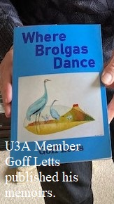
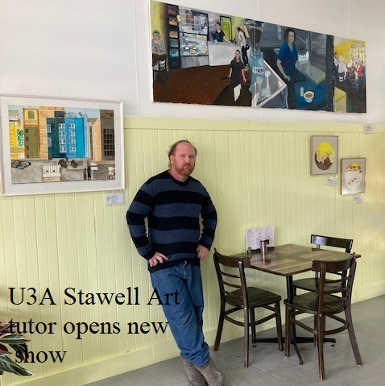

With regards to publicity we have a new listing on the Northern Grampians Shire Community Groups Page. I have talked to Ty Taylor and our film is in the running to be shown during the 2021 Seniors Festival.

