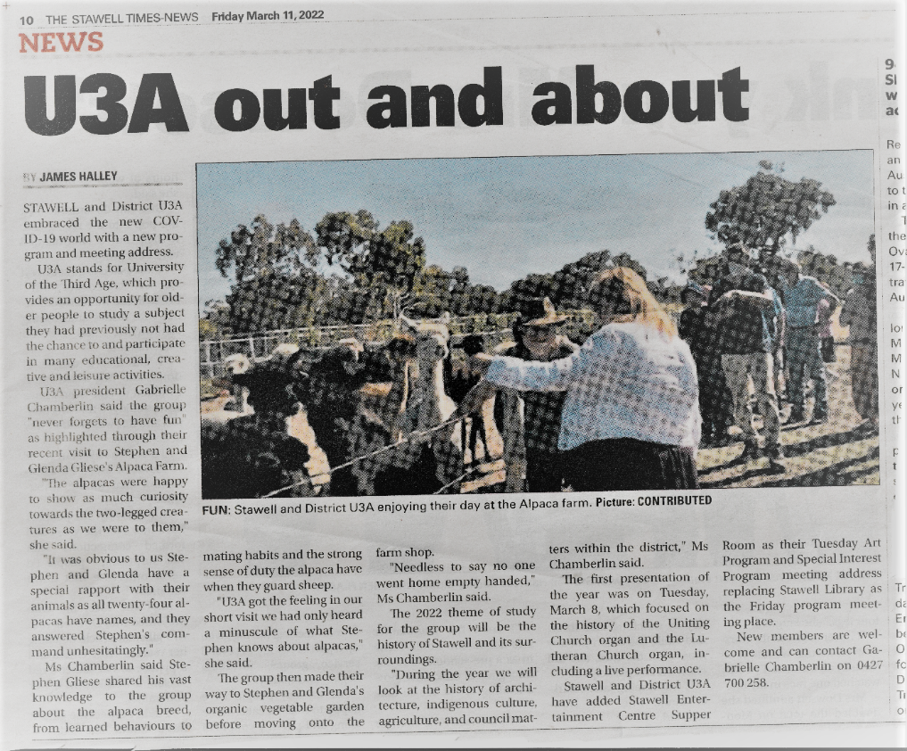
U3A STAWELL Newsletter Term 1, 2023
We started 2022 with a close encounter with Alpacas a delightful moment in time. This was a welcome return to life as we know it after Covid19. The year 2022 has seen us enjoy many great places of interest and eat some lovely foods, this is set to continue in 2023.
There is a new class set up and ready to go immediately. Joy Price will tutor a Guide to your Device class, 11.15am – 12.15pm Mondays at Stawell Library’s Temporary home Stawell Entertainment Centre. If you want to get the best from your IPhone, IPad Laptop or Tablet this could be the class for you. We have two outings planned for term 1.
A day visit to Narrapumelap Historic House and Garden followed by a byo picnic lunch in the garden. Last day of Term we are proposing a tour of the Railway Art Gallery and a High Tea/Lunch.
Our Tuesday afternoon Special Interest Programs will give us a chance to study the pioneers from any field and any era. Food for Wellness (example oranges and vitamin C). is a session where we look at food and how it is good for us then of course eat the food.
Our regular programs and classes are ongoing as is the friendliness of U3A Stawell Friendliness is the lifeblood of U3A Stawell
As we start Term 1, I am hoping we are all back to full health after our brush with COVID.
Gabby

