U3A Stawell Learn to Snap the Animals
Gabrielle Chamberlin
Thanks to the annual Be Connected Online Event Grant received this year for the first time by U3A Stawell, this out there for thinking group was able to take a picnic lunch (many thanks to Café Liv’Indi) and their devise of choice to Halls Gap Zoo. With our mobile phones, digital cameras, or whichever devise we like to use we photographed ourselves and the zoo animals, we followed the taking of photos with a session of emailing the photos to each other and to our Website, where we will eventually make a gallery page for our Facebook page and a gallery for our Web Page. U3A Stawell members who have greater knowledge of the digital world were on hand to teach those of us who would like more knowledge. As you can imagine all our frivolity caused great amusement to our selves and the animals who co- operated fully with our exercise by swinging, posing, running, fighting, and mostly laughing at us from their high perches.
When the grant to sponsor our event, during the Be Connected 2021 Get Online Week held 18th to the 24th of October, to encourage and help older persons to get more from their mobile phones, Ipads/Tablets, laptops, digital camera, and other modern technology devises, was offered to interested senior’s groups. U3A Stawell did not hesitate to apply and happily their idea for their event “Picnic, Photograph, and Publish” was approved for funding and sponsorship.
The Be Connected Organisation work to make the digital world more accessible for older persons; University of the Third Age (U3A) work to make learning fun, here in Stawell we believe our brains do not want to retire. The grant U3A Stawell has received brought us fun while exercising our brains, and I am sure the animals at Halls Gap Zoo were highly amused with our efforts to photograph them, and ourselves, although cutting heads off photos may still prove to be our superior skill.
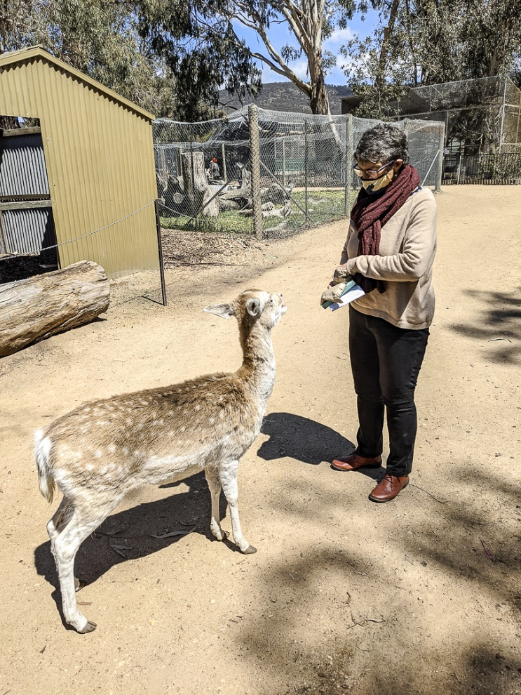
Photo 1 Betty Meumann encouraging the wildlife
to pose.
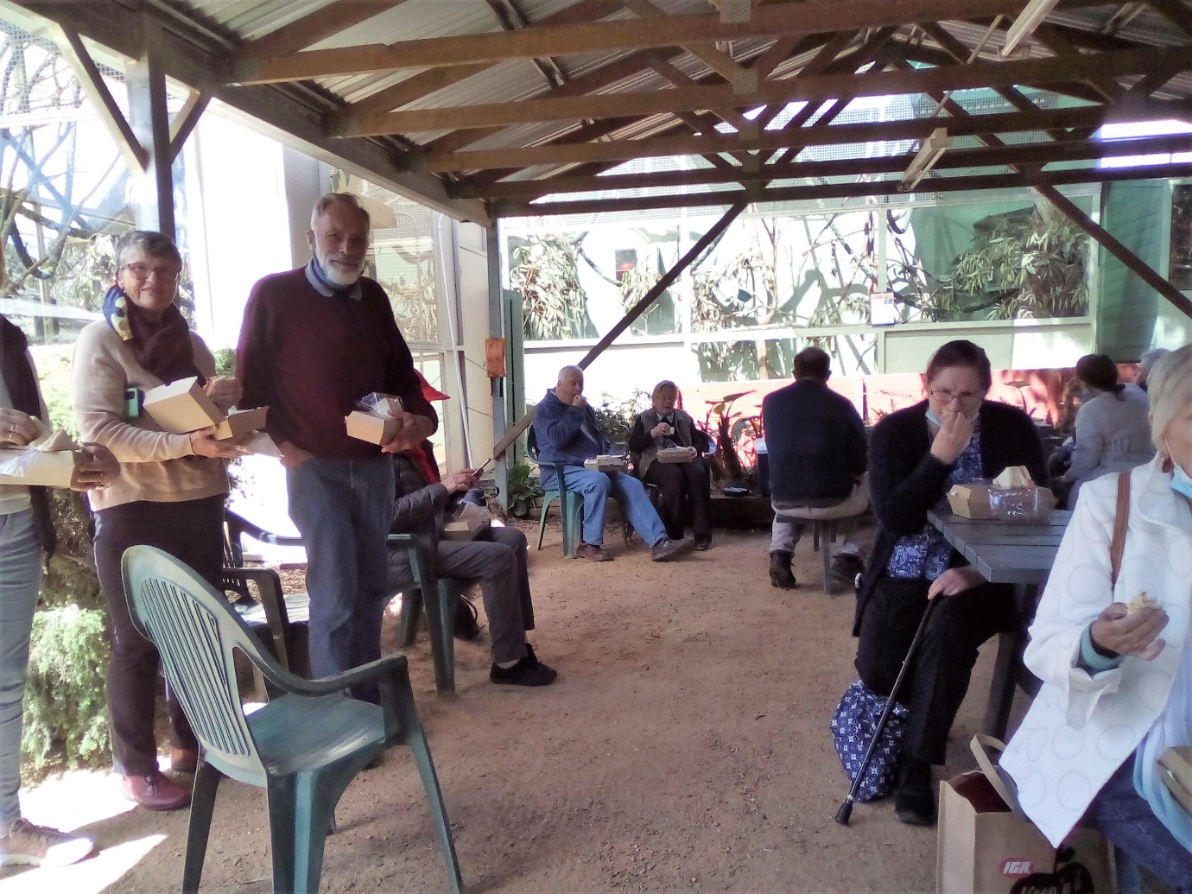
Photo 2 U3A Stawell members tuck into a delicious boxed lunch before getting down to the business of the day Photography.
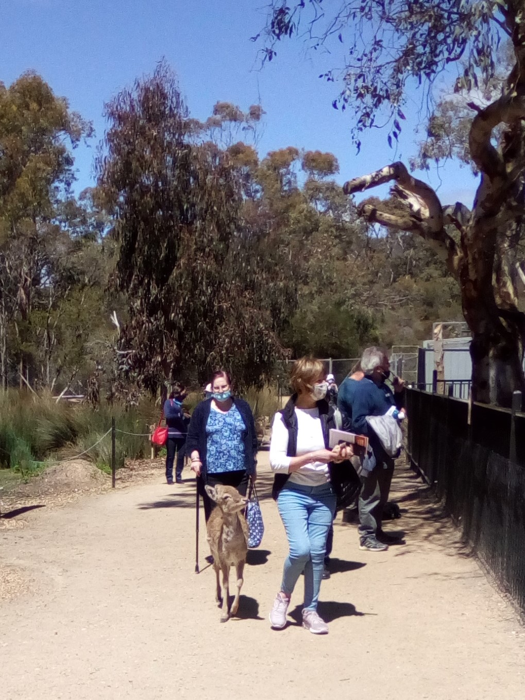

Photo 3 The beginning of the long walk around the awesome Halls Gap Zoo

